**CS405 HW2 Report**

# Task:

Turn red box to a blue box without changing html code.

# Methadology:

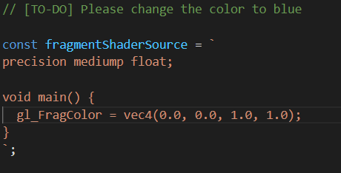

Here the gl_FragColor stands fort he color of WebGL. In vec4 respectively X means red, Y means green, Z means blue and the last one means gamma. So turning box from red to blue only needs to change X to 0 as there is no red and Z to 1 as there is blue.

# Outcome:

